**MULTIPLE PERSPECTIVES**

**Part A. Notes**. Use the PowerPoint that we go over and discuss as a class to take notes in the blank highlighted spaces below.

Big Question:

1) How do we form our _____________ about different issues or problems in society?

2) Our opinions are influenced by:

|  |
| --- |
|  |
|  |
|  |
|  |
|  |
|  |
|  |

3) A _____________ is a point of view that someone holds.

4) _____________ means that different groups of people have different points of view. It is important that we consider them when we _____________.

5) _____________ is the total of the opinions held about a certain issue.

6) If one group or individual made its perspective known on an issue, this could influence others to _____________ either by _____________ or _____________ with them.

7) Public opinion is often influenced by _____________, who are people concerned with some particular issue and who try to influence lawmakers to act in their favor.

8) Examples of these groups are:

* _____________
* _____________

9) Public opinion is also influenced by _____________ who are organizations of citizens who have similar views on many issues and who work to put their ideas into effect through government action.

10) Examples of these groups are:

* _____________
* _____________

**Part B. Applying**. In your groups, each person should select a role from the four choices below. Read the newspaper article below which talks about a problem in our communities and potential solutions to that problem using public policy. Discuss this with your group, and then answer the following questions based on the perspective from the role you have chosen.

**PARENT STUDENT BUSINESS OWNER LAW ENFORCEMENT**

**I have chosen the role of:** _____________

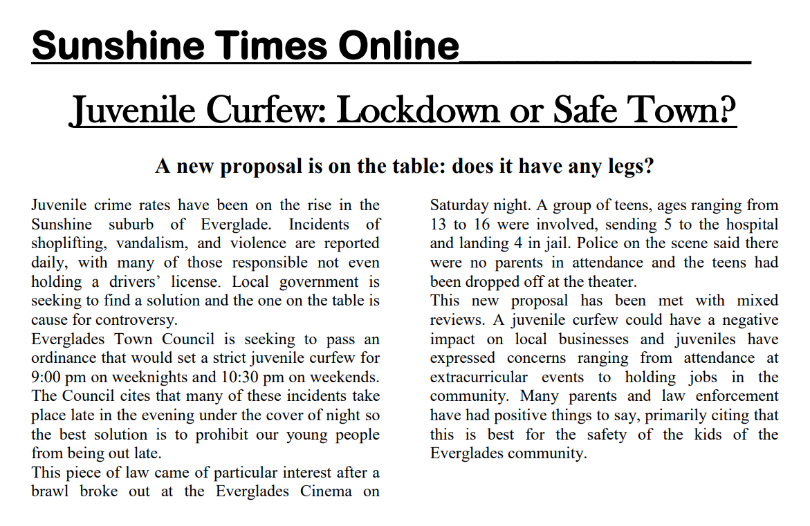

|  |  |
| --- | --- |
| QUESTIONS | ANSWERS |
| 1) What is the problem being discussed? |  |
| 2) What is my perspective on the problem? (What do I think about it? How would it affect me?) |  |
| 3) What is the proposed law/solution? What does it do to fix the problem? |  |
| 4) From my perspective, is this a good solution? Why or why not? |  |
| 5) What is an alternative solution that someone from my perspective might like? Why would this be a good solution? |  |
| 6) What might someone from the other perspectives say about this issue? |  |
| 7) Is someone from my perspective likely to participate in the political process about this issue? Why or why not? (Does this strongly affect me? Or is it something that doesn’t matter much?) |  |